Provider Network Management
Provider Network Management 1
Executive Summary 1
The Need for Effective Provider Network Management 2
The Provider Network Management Lifecycle 2
Challenges in Provider Network Management 3
Identify and Recruit Your Network 4
Provider Recruitment Steps 4
Find the Right Providers 6
Target New Providers 7
Submit Provider Requests 8
View All Leads in One Place 8
Review Leads and Move to the Next Stage 9
Credential Qualified Providers 9
Submit Credentials 10
Review Credentials 11
Verify Credentials 13
Generate and Sign Contracts 14
Secure the Deal 16
Onboard New Providers and Ensure Ongoing Success 24
Ongoing Provider Support 25
Set Up for Success 26

Executive Summary
Effective provider network management is critical to health plans’ ability to maintain adequate networks, support value-based care and deliver seamless experiences for providers and members. This document outlines how Salesforce Provider Network Management supports the full provider lifecycle: recruiting, credentialing, contracting, onboarding and ongoing support.
Cumulus’s current challenges include manual processes, fragmented and duplicated provider data, high administrative overhead and limited status transparency. New provider contracts take an average of three months to execute, while directory errors affect claims, utilisation management and care coordination. These issues also undermine provider recruitment and retention and make it harder for members to find providers suited to their needs.
The solution combines analytics, guided workflows, automation and a central provider portal to create a connected experience. Recruitment tools identify network gaps and manage leads; credentialing workflows support internal and third-party verification; and contracting tools enable reimbursement templates, approvals, version control and electronic signatures for fee-for-service and value-based arrangements. Onboarding connects provider information with downstream systems and delivers role-appropriate training, while ongoing support includes renewal and recredentialing reminders, claims services, live chat and case resolution.
Together, these capabilities are intended to reduce repetitive administration, improve data consistency and process visibility, and strengthen provider and member experiences. Configurable business rules, work guides and integrations allow health plans to adapt the approach to their operating requirements while maintaining a single system of engagement across the provider journey.

The Need for Effective Provider Network Management
Today, effective provider network management goes beyond the simple recruiting of providers, and it forms a critical part of the payer value chain. Not only must health plans bring providers into their networks, they must also provide seamless digital experiences for members and providers alike to complete critical tasks before and after care. To enable value-based care, health plans must be able to evaluate providers with accurate data across a number of factors. And with increased regulatory requirements around access and adequacy, health plans also need sophisticated analytics tools to assess their network as a whole.

The Provider Network Management Lifecycle
The key stages of provider network management are Recruiting, Credentialing, Contracting, Onboarding, and Ongoing.
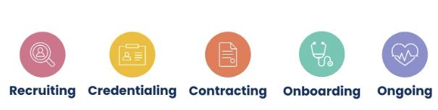
Stage | Goal
Recruiting | Identify and recruit prospective providers.
Credentialing | Collect and verify provider credentials.
Contracting | Create, negotiate, and sign provider contracts.
Onboarding | Set up new providers to successfully participate in the health plan.
Ongoing | Keep providers engaged and successful.

Provider Network Management provides distinct experiences for different users.

Challenges in Provider Network Management
With the key stages in mind, let’s take a look at common challenges in provider network management. This table lists some problems Cumulus currently faces.
Problem | Description
Slow processing times | Manual processes and poor communication experiences create provider friction and slow turnaround times at all stages.  On average, it takes Cumulus 3 months to execute a contract for a new provider.
Poor data quality | Cumulus’s provider directories are error-prone, with duplicated and disconnected data the norm.  These errors have downstream implications on other key payer operations, such as claims, utilization management, and care coordination.
High overhead costs | Cumulus spends extensive resources simply maintaining its existing provider directories, due to the disparate data sources and complexity of its network.  Cumulus must constantly expend resources to meet regulatory requirements and avoid violations and fines.
Low provider satisfaction | Due to disjointed processes and lack of status transparency, providers are increasingly dissatisfied with Cumulus’s network management solution.  Many existing providers are opting to leave the network knowing that there are better experiences available. And Cumulus is finding it difficult to recruit new providers who expect far more self-service and automation.
Low member satisfaction | Provider relationships greatly influence member relationships. For health plans like Cumulus, member relationships are only as strong as the network that enables them.  Moreover, Cumulus members struggle to search for providers based on unique health needs, resulting in a lower quality of care.

Identify and Recruit Your Network

Provider Recruitment Steps
For a provider network to be successful, the recruitment team must have tools to:
- Analyze its existing network.
- Identify network gaps.
- Develop campaigns to attract top providers.
- Build personalized workflows and interactions to support the application process.
Here are the main steps that the recruitment team must take to recruit providers.
- Target new providers.
- Submit provider request.
- View provider leads.
- Segment and assign leads.
- Review leads.
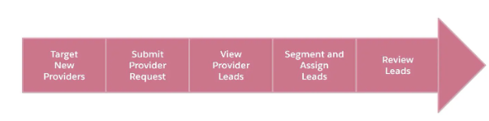
Provider Network Management offers a variety of resources to support payers across every step of the recruitment process. Let’s find out how Provider Network Management helps recruiters at each step.
Step | How Provider Network Management Helps
Target new providers. | To build a robust and effective network, health plans need to identify high-value candidates to bring into the network.  Using CRM Analytics, recruiters can use dynamic analytics tools to set specific criteria, evaluate network adequacy, and identify high-value providers.
Submit provider request. | The opportunity for network growth also happens organically.  An inbound provider request involves a provider who reaches out directly to a health plan about becoming a participating provider.  To make this request simple and quick for the provider, Provider Network Management provides guided workflows that launch from a payer portal or website.
View provider leads. | Provider leads come from a variety of sources: hospital systems, list purchases, competitive analysis, and more.  Regardless of the source, Provider Network Management enables the recruiting team to view and manage their provider leads in a single place.
Segment and assign leads. | Using embedded analytics tools, the recruitment team segments their provider lead lists across various characteristics such as geography, type, and specialty.  Lead assignment and skill-based routing rules then assign the leads to the appropriate recruitment specialist.
Review leads. | With lead management and CRM Analytics, recruiting specialists can review assigned leads and identify any missing information.  Then, thanks to dynamic workflows, the assigned specialist can reach out to the provider and collect any missing information. The data collected can then trigger automated workflow rules that progress the provider into the credentialing stage.

Find the Right Providers
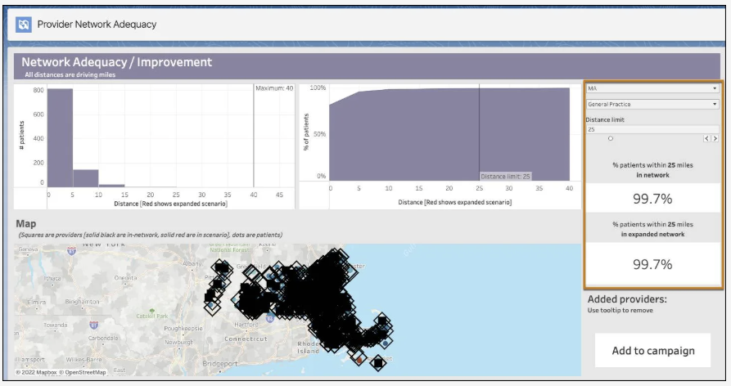
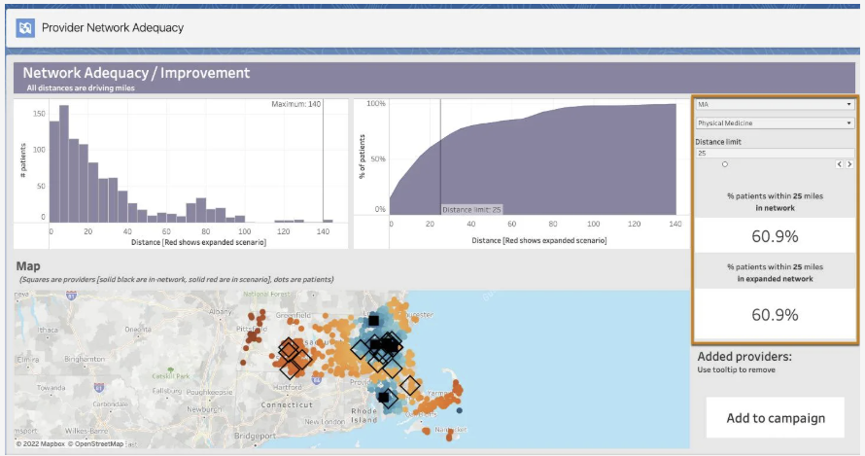
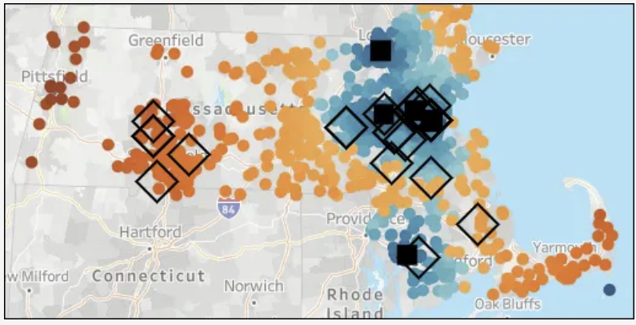
The map color codes the members to illustrate their proximity to a physical medicine provider. Members in dark blue are closest to the provider specialty, while those in dark red are the furthest away from the provider specialty.
The map also captures in-network and out-of-network providers. The in-network providers are represented by the filled-in squares. Those providers who are not a part of the network are represented by the outlined diamonds.

Target New Providers
Automating key moments in the recruitment process allows payer organizations to efficiently scale without overburdening the recruitment team with a heavy volume of repetitive tasks. It frees the team up to focus their time and effort on more personalized communication. And they can analyze the effectiveness of campaigns to make continual improvements. Pretty powerful stuff.
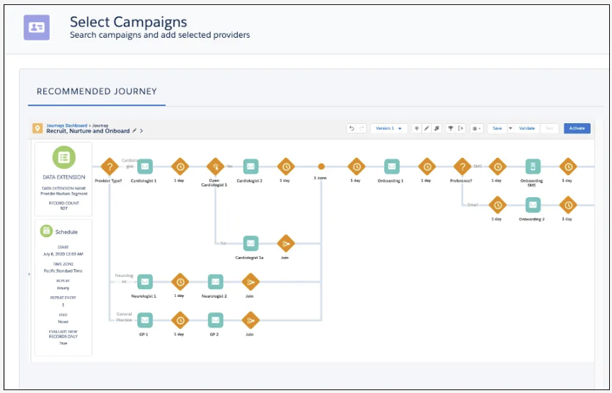

Submit Provider Requests
Outbound requests are campaign-initiated journeys targeting specific providers to attract them to submit a Provider Request.
Inbound requests are called “push” requests, in contrast to the “pull” model, which involves more active recruitment by the provider.

View All Leads in One Place
The Provider Recruiting dashboard to segment analyzes leads across key metrics, such as source, specialty, campaign, and date. The dashboard gives recruitment specialists dynamic visualizations into prospective providers.
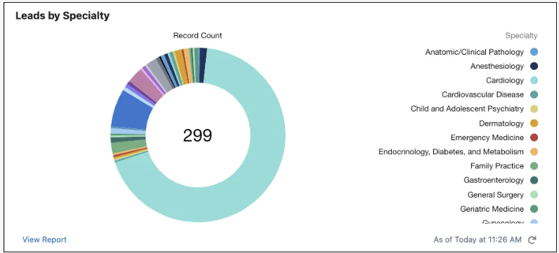
Providers come in all shapes and sizes–hospitals, group practices, individual practitioners–and it’s important for recruitment teams to have a strategy to assign the appropriate recruiting resource.
Automation rules allow to assign the segmented leads to the appropriate recruiting specialists based on provider characteristics such as geography, type, and specialty.

Review Leads and Move to the Next Stage
After receiving notification of the new provider lead assignment, Representatives visit doctors lead record page. It contains information captured from the registration and Einstein Discovery forecasts that predict doctors likelihood to join the network.
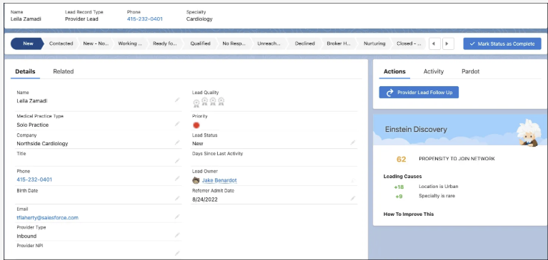

Credential Qualified Providers
After a health plan recruits providers to its network, it must ensure that these providers have all the right credentials. In a provider context, credentials refer to all the licenses, certifications, education, and registrations a provider must have. In such a heavily regulated industry as healthcare, there are many required credentials so it’s important for payers to conduct a rigorous verification process.
With this credentialing solution, payer organizations can use prebuilt workflows and other tools to simplify and streamline credentialing tasks.
The key steps in provider credentialing are:
- Submit credentials.
- Review credentials.
- Verify credentials.

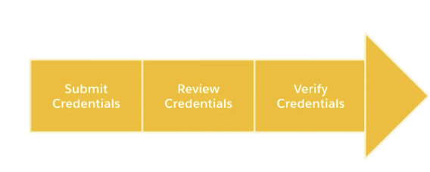
Step | Summary
Submit credentials. | The prospective provider submits all the required credentialing information through an application workflow from their provider portal.  Health plans can partner with a credentialing organization to greatly simplify this task, with most of the work done automatically after the provider enters his or her ID.
Review credentials. | After the provider submits the application, all the credentialing information automatically populates the provider’s contract record.  From there, the credentialing specialist accesses and reviews all the submitted credentials in one central location.
Verify credentials. | Health plans verify credentials internally, partner with a third party, or use a hybrid approach with some details verified by a third party and others verified internally by the credentialing specialist.  Guided workflows, pre-filled information, and knowledge article suggestions assist the credentialing specialist with manual verification items.  For items handled by a third party, the health plan configures business rules to streamline the process and monitor status in real time.

Submit Credentials
At the end of the recruitment phase, the recruitment specialist converts the doctor into a lead record to a contact, account, and user. This conversion initiates the credentialing process. The doctor automatically receives an email that invites them to join the provider portal.
They click the link, sets their password, and gains access to the portal.
Their portal is personalized, and all the tasks and information focus on credentialing. The portal presents her with a To Do List that provides a link to any unfinished tasks.
Doctors enter their Centers for Affordable Quality Healthcare (CAQH) ID and their credentials appear automatically. CAQH is a credentialing database leader. The Provider Network Management data model supports integration with CAQH, which is enabled after the Payer configures the connection and supplies its credentials. After entering her CAQH ID, doctors review their credentials and submits the form.

Review Credentials
Payer may use a hybrid approach to credential verification, with some details verified by a third party and others verified internally by credentialing specialists. The payer’s business rules require that a credentialing specialist must first review and confirm credential details before sending anything for third-party verification.
Payers may use automation rules to route provider verification to queues based on a variety of provider attributes. Different credentialing specialists are then assigned to different queues. Different credentialing application routes to different queues for English-language credentialing cases.
Credentialing specialist at Payers, logs in for the day and reviews key metrics and cases on their home page. They are member of two verification queues, including the Credentialing English Language queue. They investigate doctors credentialing case at the top of their queue.
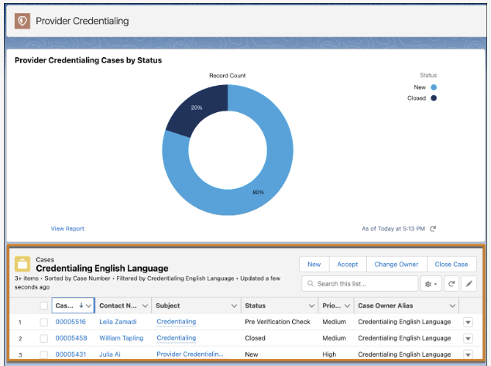
On doctor’s case record, a work guide clearly lists out the key tasks that the credential specialist needs to complete. The Supervisor designed this work guide using Salesforce’s Flow Orchestration tools. With Flow Orchestration tools, users can create work guides to simplify complex processes that involve multiple stages and users.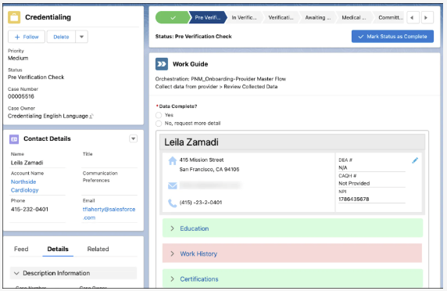
At the top of the record, a path tracks the stages of the credentialing process. Doctors case currently sits in the Pre-Verification Check stage. Just as with the work guide itself, the implementation team can easily customize these paths to match a payer’s exact credentialing process.
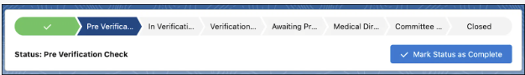
The Credential specialist performs an initial check of doctors’ information by expanding the category blocks at the bottom of the work guide. Much of their information displays in green, but her work history appears in red due to some missing information. The specialist makes a note to fill in this missing information.
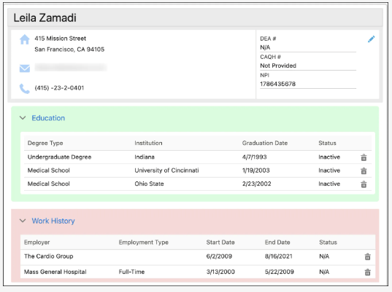
With the initial review complete, it’s time to verify the credentials.

Verify Credentials
The credentialing specialist reviews the data first before sending certain key verification tasks off to a third party via API. For those manual verification items, Payers use a number of Salesforce tools to speed things up.
When the specialist validates the work and education history for doctors, they do it with the support of guided workflows that have pre-filled information for validation and contextual knowledge article suggestions for each step.
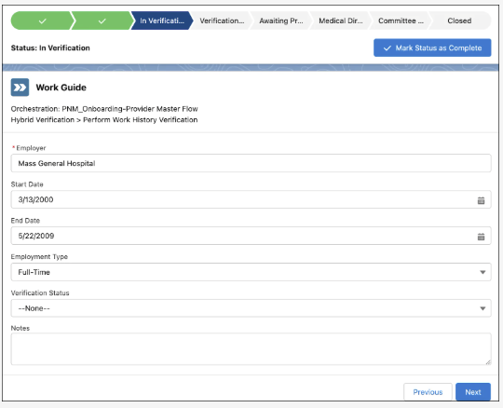
All of the fields and values are fully customizable, and it’s easy to modify work guides to match your precise business process. For those items that require third-party verification, the credentialing specialist can easily check their real-time status. Ultimately, automated and specialist-led steps come together to efficiently complete credentialing for doctors.
The credentialing process has also provided the Payers with the insights needed to initiate the contracting experience, which comes next.

Generate and Sign Contracts
After a health plan verifies a provider’s credentials, it’s time to secure the terms of the agreement and sign a contract. There’s a lot that goes into this phase of provider network management. Provider Network Management provides workflows and tools at every step to make sure it all proceeds as transparently and smoothly as possible.
The solution helps health plans establish financially sound arrangements and supports a variety of contract types, including fee-for-service (FFS) and value-based contracts (VBC).
Here are the main steps of provider contracting.
- Establish terms.
- Generate contract.
- Conduct internal review.
- Deliver contract.
- Modify contract.
- Sign contract.
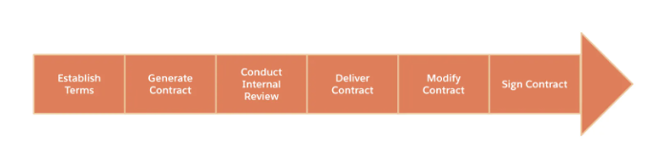
Step | Summary
Establish terms. | Establish the precise reimbursement terms for a provider contract.  Specialists use reimbursement management tools to enable reimbursement calculation based on different types of contracts. Salesforce offers standardized support for many different reimbursement types.
Generate contract. | Create the actual contract document.  Contracting specialists use templates to easily create and maintain different types of contracts and then use specific clauses and reimbursement terms for specific providers.
Conduct internal review. | Contracting managers and other internal stakeholders review and approve the contracts. Naturally, different health plans have different approval processes in place for internal reviews.  Payers can set up flexible business rules to automate who receives approval requests and when. Other tools, such as bell notifications, automated emails, and approval list dashboards, all work together to ensure expedited reviews.
Deliver contract. | When the contract is approved internally, the health plan delivers the contract to the provider for review and signature.  Integrate seamlessly with electronic signature applications such as DocuSign to make the contract process fully paperless.  The provider can review the terms of the agreement and propose changes directly from their provider portal.
Modify contract. | The contracting specialist makes changes and easily routes the contract back to manager review. When reviewing the revised contract, the manager accesses a quick view of the history of contract changes, enabling them to quickly approve the new version. Versioning of contracts and change identification tools ensure no other updates go unnoticed.
Sign contract. | Everyone signs the contract and celebrates the win.  Once again, integrations simplify and expedite the signature process.

Secure the Deal
Payers are now ready to create, negotiate, and execute a contract with doctors. Let’s focus on how Provider Network Management tools enable the team to perform the following key actions.
- Establish provider reimbursements.
- Generate the contract.
- Complete network affiliations.

Establish Provider Reimbursements
The contracting specialist at the Payer, starts their day by visiting the Contracting Specialist dashboard. This dashboard contains searchable list views for all recent contracts and cases, which the specialist can easily filter.
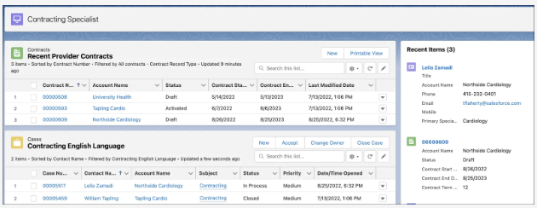
At the top of Connie’s contracting queue is the doctor case, so they open it up. The case record contains data and details associated with the doctor information. Just as with the credentialing process, you can set up work guides to support users through all the steps. For example, the first step in Payers contracting work guide is to select the appropriate Payment Reimbursement Template.
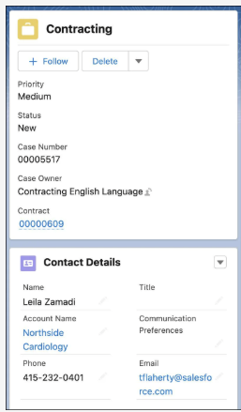 | 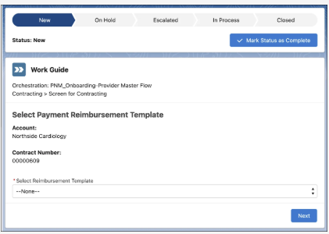
For a new contract, the contracting specialist must generate the appropriate contract payment agreements. Thankfully, the team at the Payer has already created a number of templates to rapidly set up relatively complex rates.
For doctors’ case, the specialist selects the Advanced Incentive Reimbursement template, which offers the most advanced and flexible options. After the specialist selects the template, dedicated services assign contract payment agreements and term line items to the contract. Seven contract payment agreements and 11 payment agreements are added to the contract.
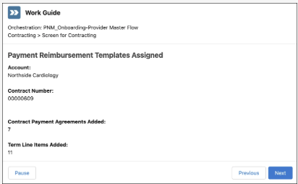
On doctor’s account, the specialist reviews the Contract Payment Agreements, which store information about the payment types: a list view of all the agreement records, each with a different agreement type.
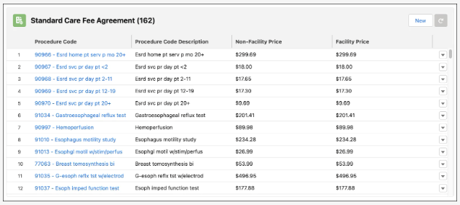
Salesforce makes it remarkably simple for the contracting specialist to instantly assign all base rates and incentives to any new provider contracts.

Generate the Contract
After reviewing the terms, the specialist is ready to generate the contract. The Payer embeds a handy OmniScript within the work guide, which covers the following steps.
- Choose contract template.
- Select contract conditions.
- Select contract causes.
- Enter custom clauses.
- Preview the contract.
Back on the case record, Connie clicks Generate Contract to get started.
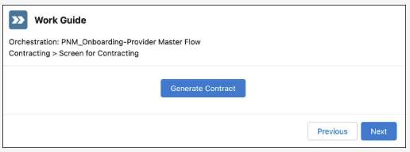
A new workflow appears, prompting her to select a contract template, which has been preconfigured by the contracting team. Specialist finds a number of contract templates available for selection.
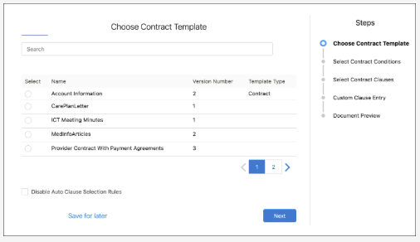
The specialist selects the Provider Contract with Payment Agreements. This contract template maps perfectly with the payment reimbursement details that they selected earlier.
You can further customize any contract by adding a number of predefined conditions that are specific to a template. The specialist selects five contract conditions that apply to doctor context.
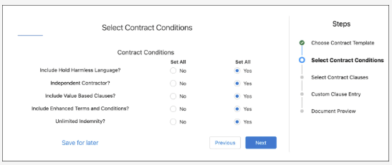
You can also add predefined clauses not specific to the contracting template. Here, Connie adds a COVID-19 Addendum.
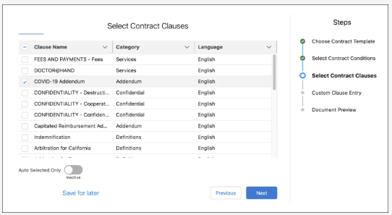
Similarly, you can easily create and insert multiple custom clauses that only apply to a specific contract.
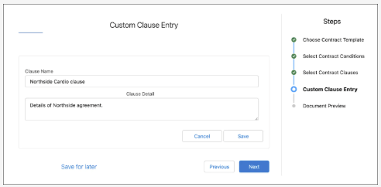
After confirming the contract details, the specialist must preview and download a document that contains all the additional conditions and clauses, and the assigned rates. Before downloading the document, they previews doctor’s contract directly from the workflow.
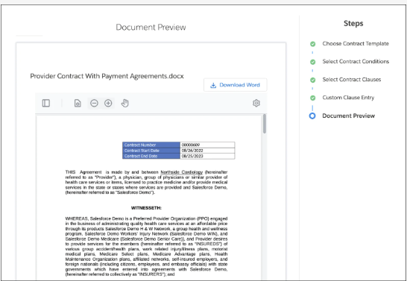
In the contract appendix, she looks at the fee agreements, all clearly laid out in a table.
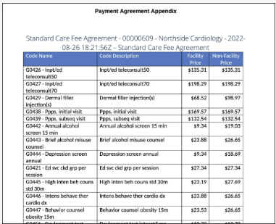
When the specialist verifies all is in order, they proceed to download the document. Back in her work guide, she clicks the Finish button, which initiates the internal approval process for the contract.
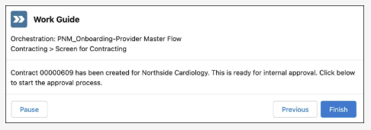
The Specialist contracting manager immediately receives a notification about the approval request. With a single click, the manager navigates to the approval request record. From there, he can easily access the contract, review the terms, and approve, reject, or reassign the request.
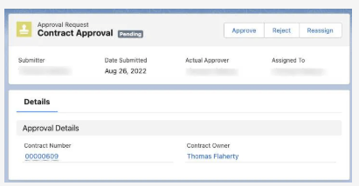 | 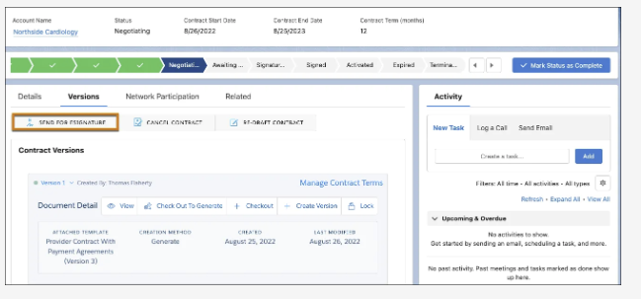
If there are change requests, users can easily create a new contract version and revise as needed. In this case, though, the specialist’s manager finds everything in order and approves the contract. With the internal review complete, the contract can now go to the provider for review. Once again, Connie performs this directly from the contract record.
For handling the e-signature process, Salesforce supports a number of integrations, including DocuSign.
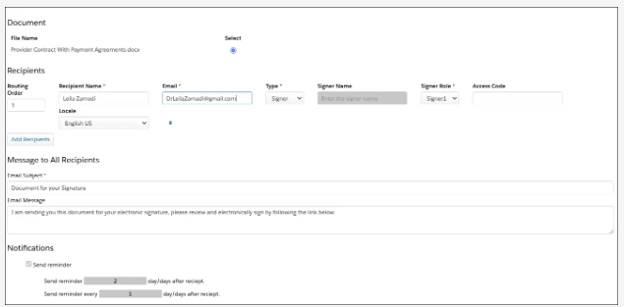
Doctors receive an email notification that the contract is ready for review. If they have any issues with any of the clauses or rates, they can reach out to the specialist. After negotiation, the specialist can create a new contract version from the original one.
After some back and forth, the doctor approves the final terms and signs the contract. Connie receives a notification and a request to activate the contract. On the contract record page, a PDF of the signed contract attaches to the appropriate version. With everything signed, sealed, and delivered, the specialist activates the contract with a simple click of the Activate button.
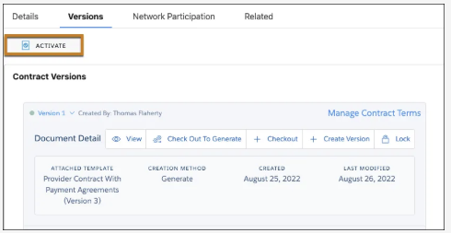
Complete Network Affiliations
As a final step in the contracting process, then, the contracting specialist must designate which network affiliations the new provider will join.
Once again, the trusty work guide is ready and waiting on the case record.
The specialist simply selects the particular doctor participating networks and specifies the start date.
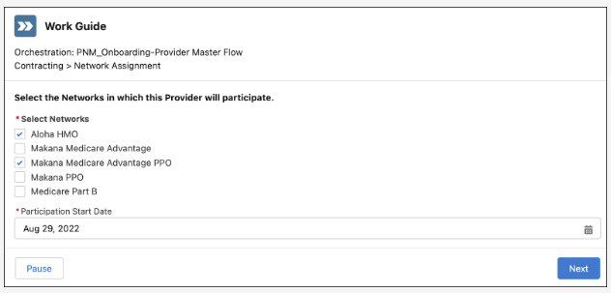
Under the hood, dedicated services create healthcare facility records that link the contract, practitioner, facility, and payer networks all together. These new records appear on the Network Participation tab of the contract record page.
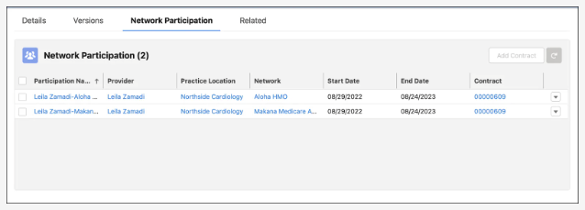

Onboard New Providers and Ensure Ongoing Success
Once the provider contract is signed, payers must pave the way for provider success through a personalized and effective onboarding program. The exact onboarding steps and actions may vary based on the attributes of the payer. Initiating a go-live program in the same system as the full provider onboarding journey makes handling those dynamic decisions efficient.
Although the specifics often vary, there are some common steps we can look at more broadly. Here are the key steps of provider onboarding.
- Integrate data.
- Assign coordinator.
- Activate provider portal.
- Provide training and enablement.
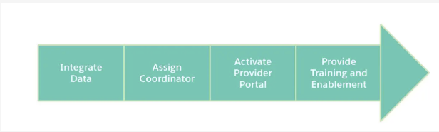

Step | Summary
Integrate data. | Automatically route the appropriate data to the appropriate downstream systems.  For example, deliver provider reimbursement terms to the claims system.
Assign coordinator. | Assign the appropriate provider coordinator based on provider characteristics and other factors.
Activate provider portal. | Provide a central portal that has all key actions and communication needed to complete the onboarding and perform other key tasks.
Provide training and enablement. | Deliver effective training and enablement on key processes and practices.

Ongoing Provider Support
After the onboarding of new providers, health plans must continue to deliver solutions to ensure their ongoing success.
Here are the key steps of ongoing provider support.
- Configure automated reminders.
- Enable claims services.
- Embed live chat.
- Provide support and resolution.

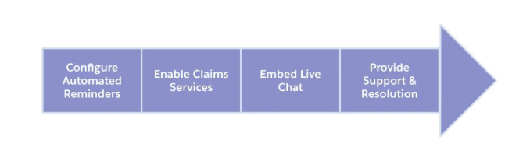
Step | Summary
Configure automated reminders. | Deliver automated reminders to providers via their preferred channel of communication.  For example, send reminders about actions needed around contract renewal and recredentialing.
Enable claims service. | Support integrations to facilitate claims display and intake in a provider portal.
Embed live chat. | Embed live chat in a provider portal and give providers the chance to resolve issues in a snap.
Provide support and resolution. | Use case management and routing tools to initiate, manage, and resolve all cases faced by providers.

Set Up for Success
To enable various welcoming activities, Cumulus relies on a number of Salesforce tools. And it’s not only the provider that needs onboarding, but also the provider office team who handle key tasks such as scheduling, billing, and claims.
Broadly, the Payers onboarding experience falls into the following two categories.
- Set up integrations for communicating with the provider’s downstream systems that handle key processes like claims.
- Deliver training and communication to the provider and team to ensure they can successfully complete all key tasks.
In this section, we focus more on the second category, since the specific integrations needed for different organizations can vary greatly.
Just like the other specialists at the Payer has their own personalized Go Live Specialist Home page where they can easily access his queue and perform other key onboarding actions.
The specialist starts their day by diving into doctors Go Live case record. Conveniently, the work guide is waiting for him with a list of onboarding tasks to complete.
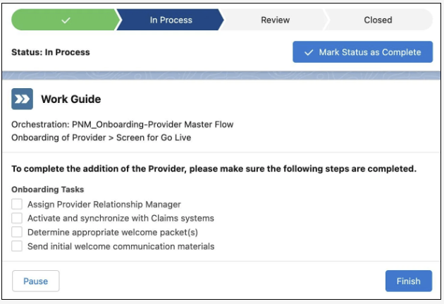
In a real implementation, the list of onboarding steps can be much longer. The key thing to note is how flexibly the Flow Orchestration and case management tools meet different needs across all stages, while giving all users an integrated experience.
To further support new providers, health plans can easily set up a variety of resources on the provider portal.
Over the next week, the doctor and their team regularly visit the portal to complete the training, which is delivered via enablement sites. Enablement sites deliver unique learning content through a branded experience. Searchable FAQs, documentation, and knowledge articles provide additional information. And thanks to embedded chat, their team can reach out and receive more advanced in-context support whenever they need it.
Everyone on the doctor’s team knows exactly what to do when they run into issues and feel supported every step of the way. Just last week, they had a question about a claim reimbursement. The provider portal enables fast, in-context communication so they initiate a chat for the claims inquiry.
When the chat is received, it automatically routes to a queue specialized in handling such provider inquiries. The support agent who takes on the inquiry is empowered with access to real-time data via integration, contract terms for doctors, and knowledge article recommendations. Together, they are able to resolve the question in a few minutes.
Doctors and their team now have a lot more time to focus on patient care. And the Payer has total confidence in its provider data, actionable insights, and single system of engagement. It’s truly a win-win-win for payers, providers, and members alike!

